MACHINE LEARNING ASSIGNMENT 1

SAGARIKA SRAVANI MENNEKANTI

700741376

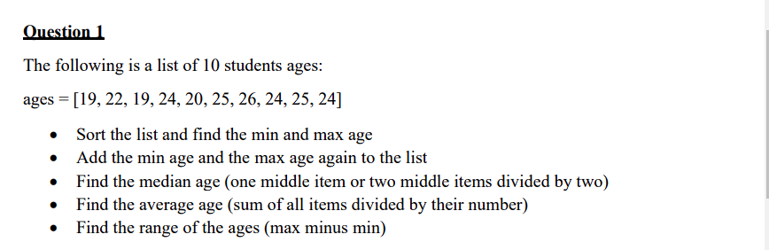

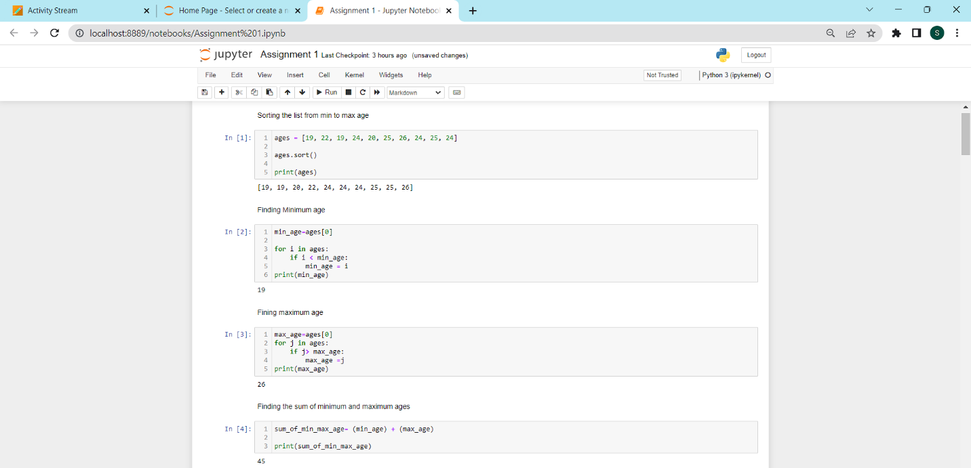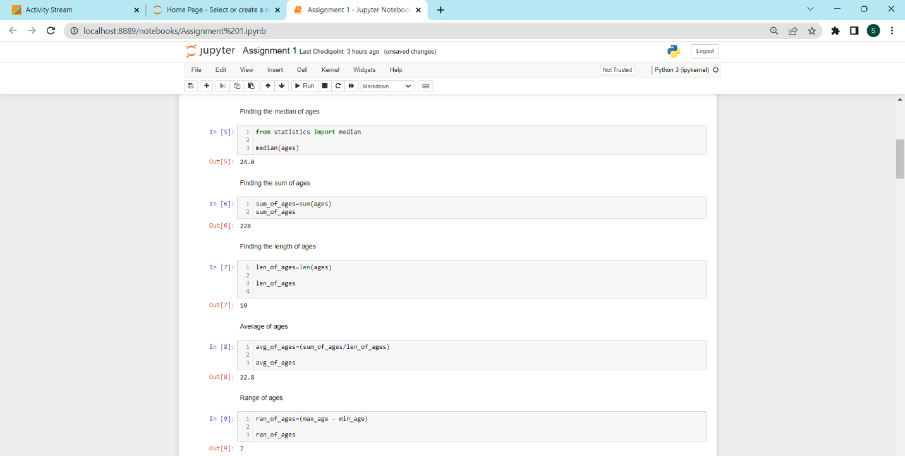

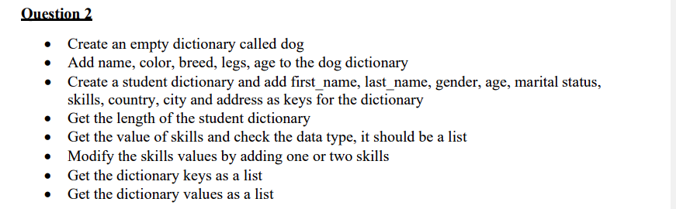

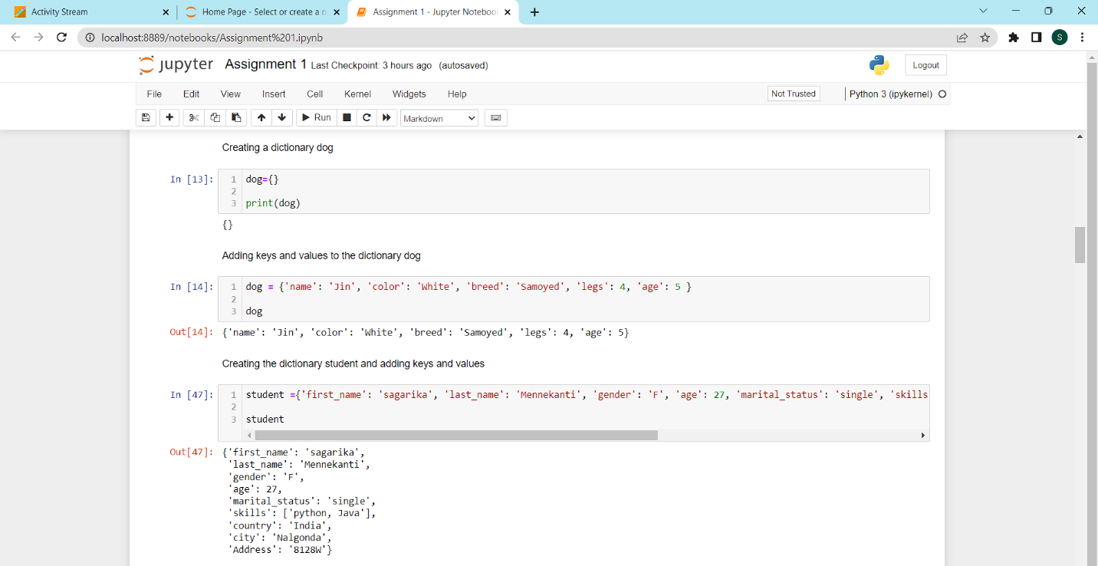

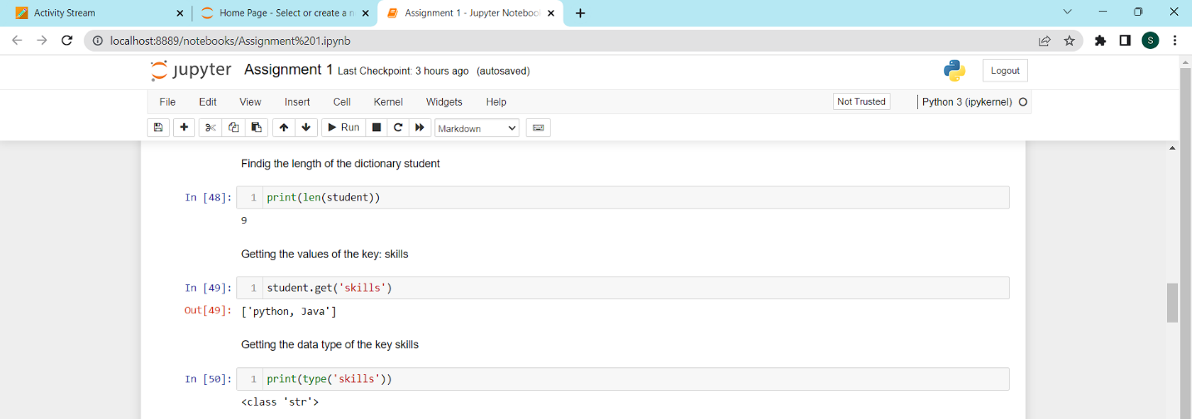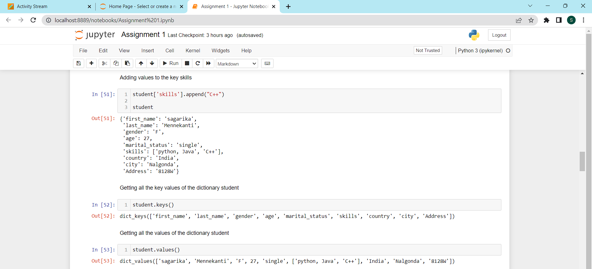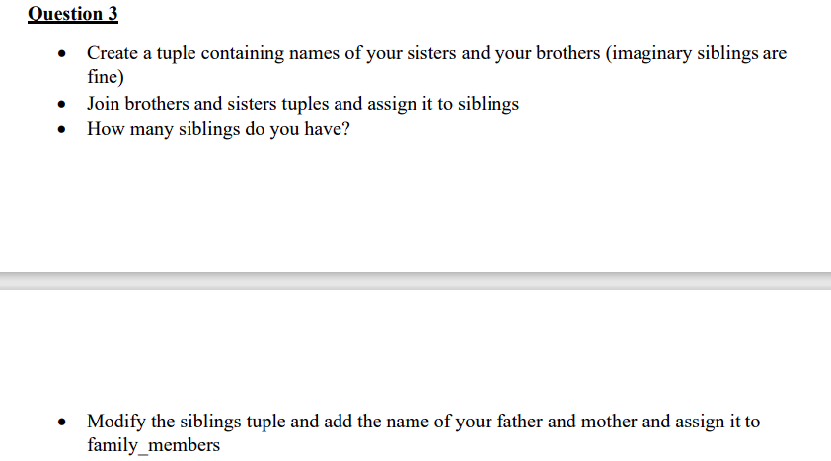

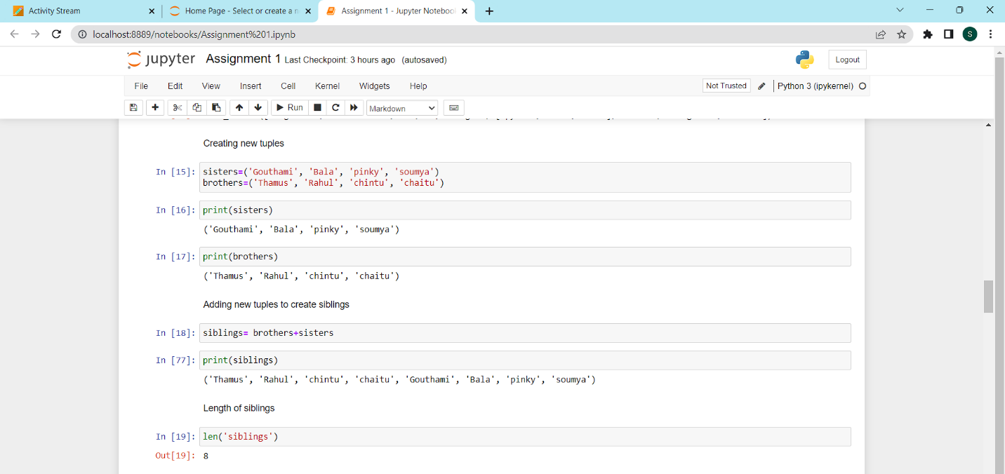

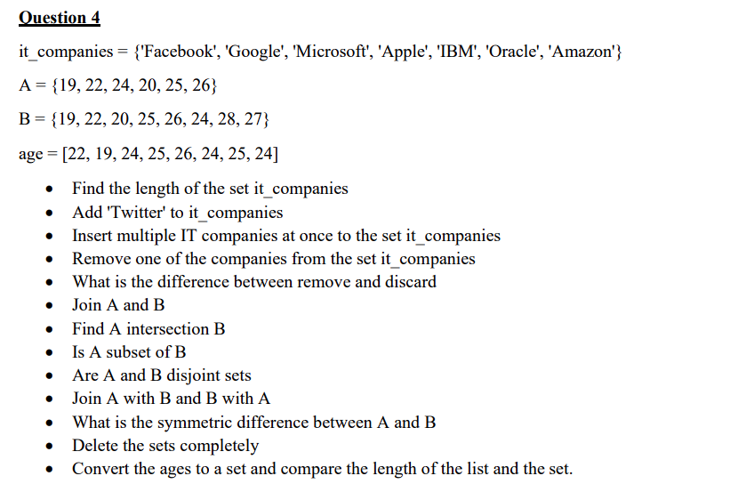

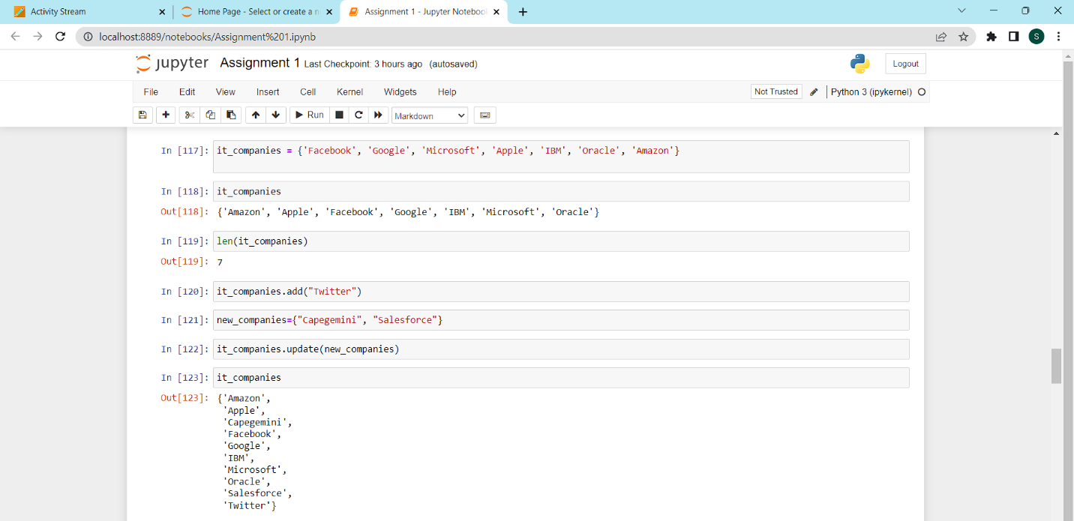

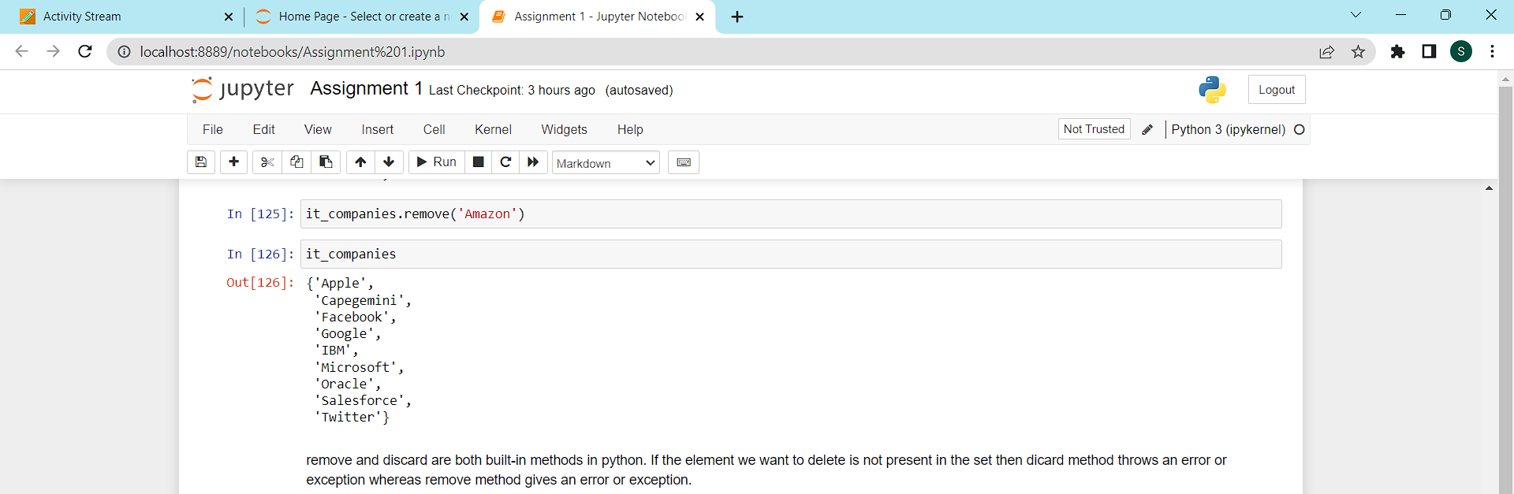

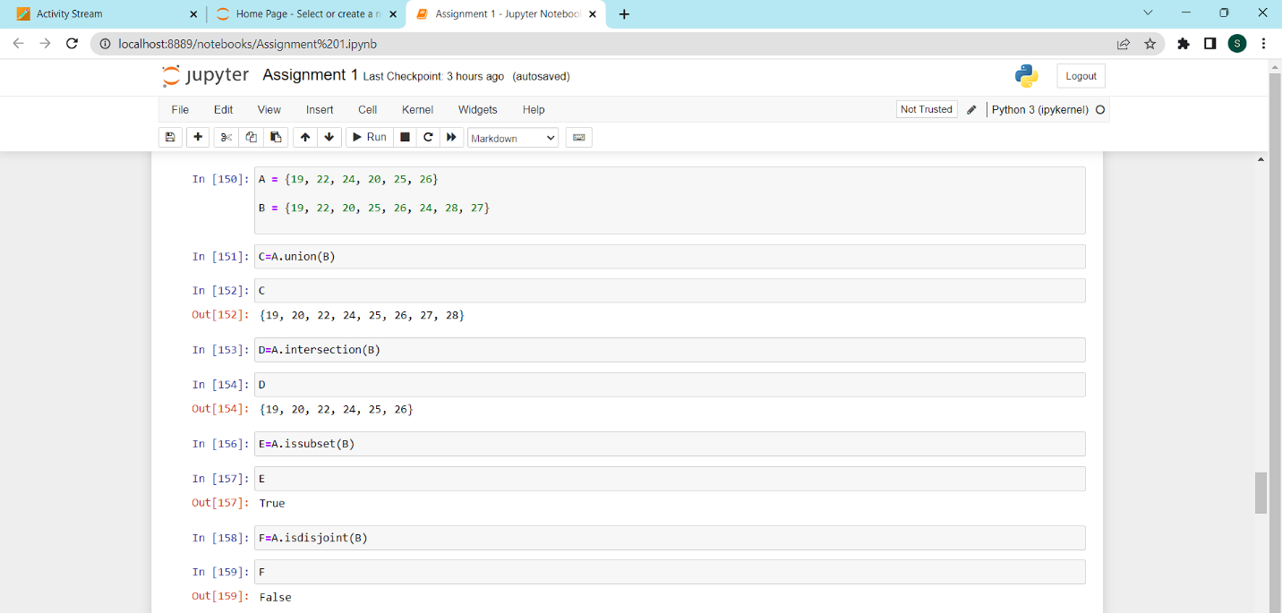

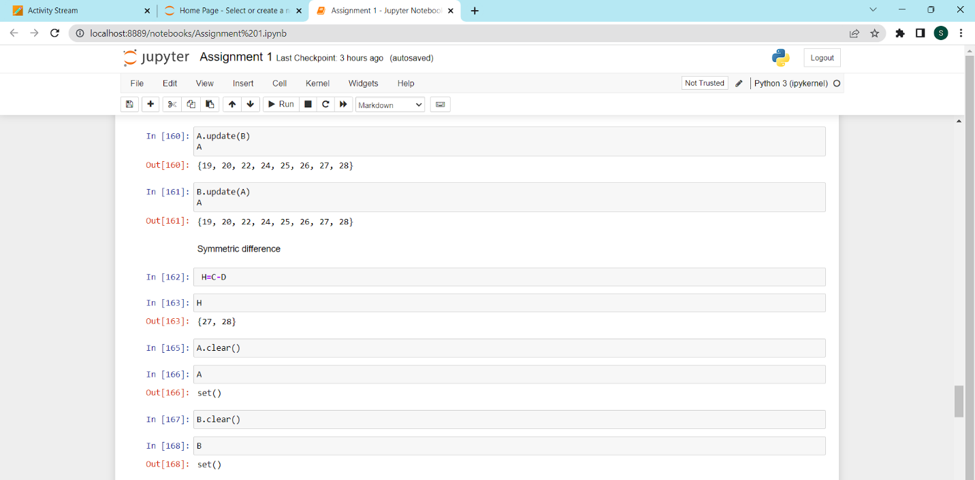

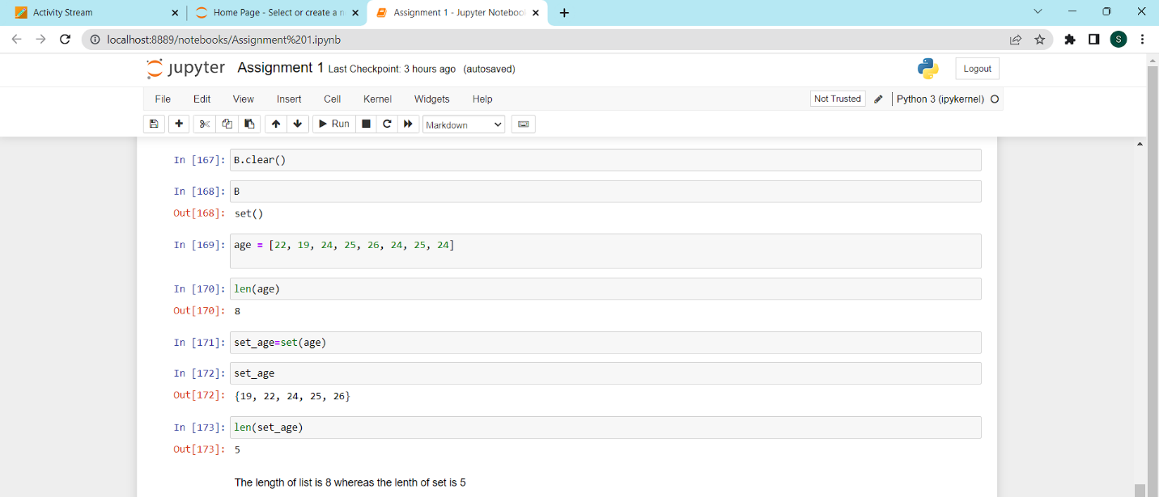

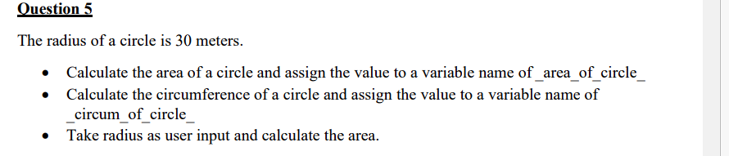

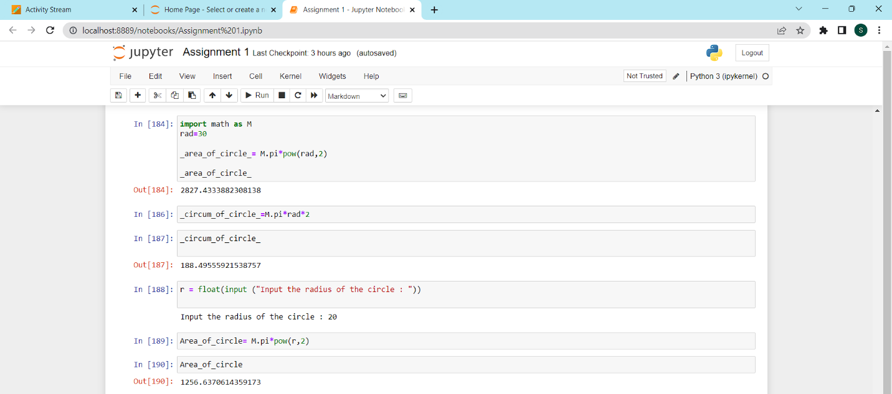

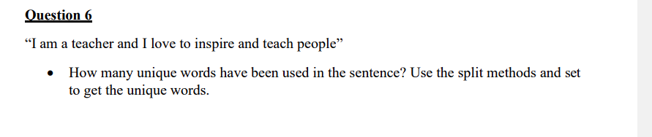

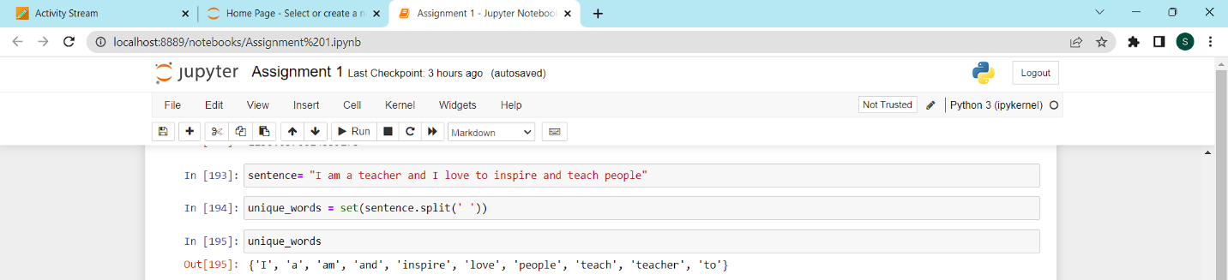

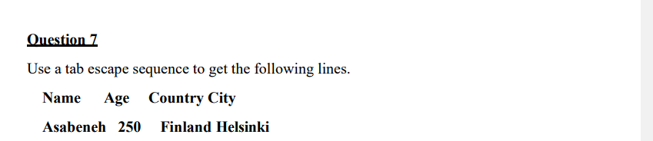

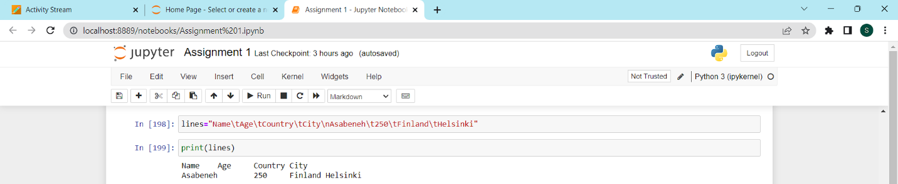

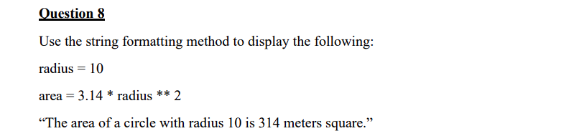

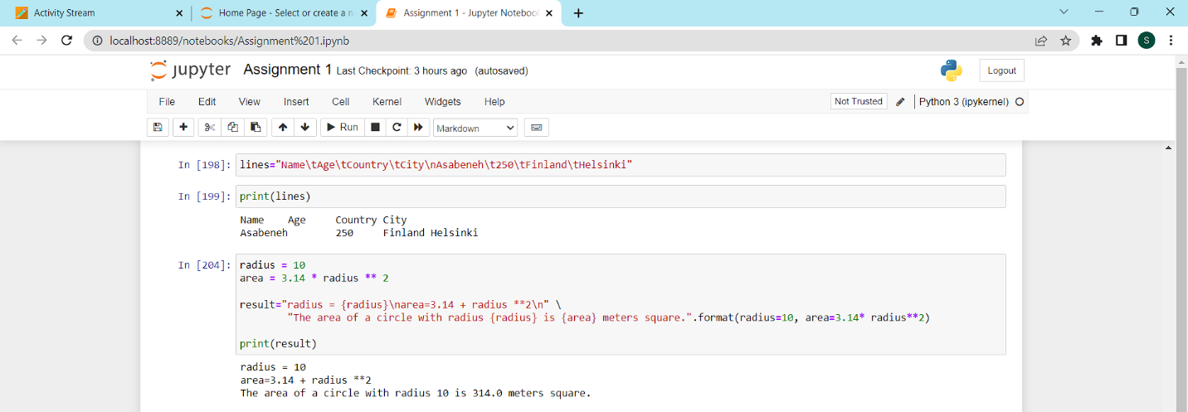

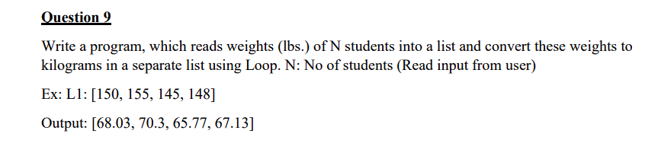

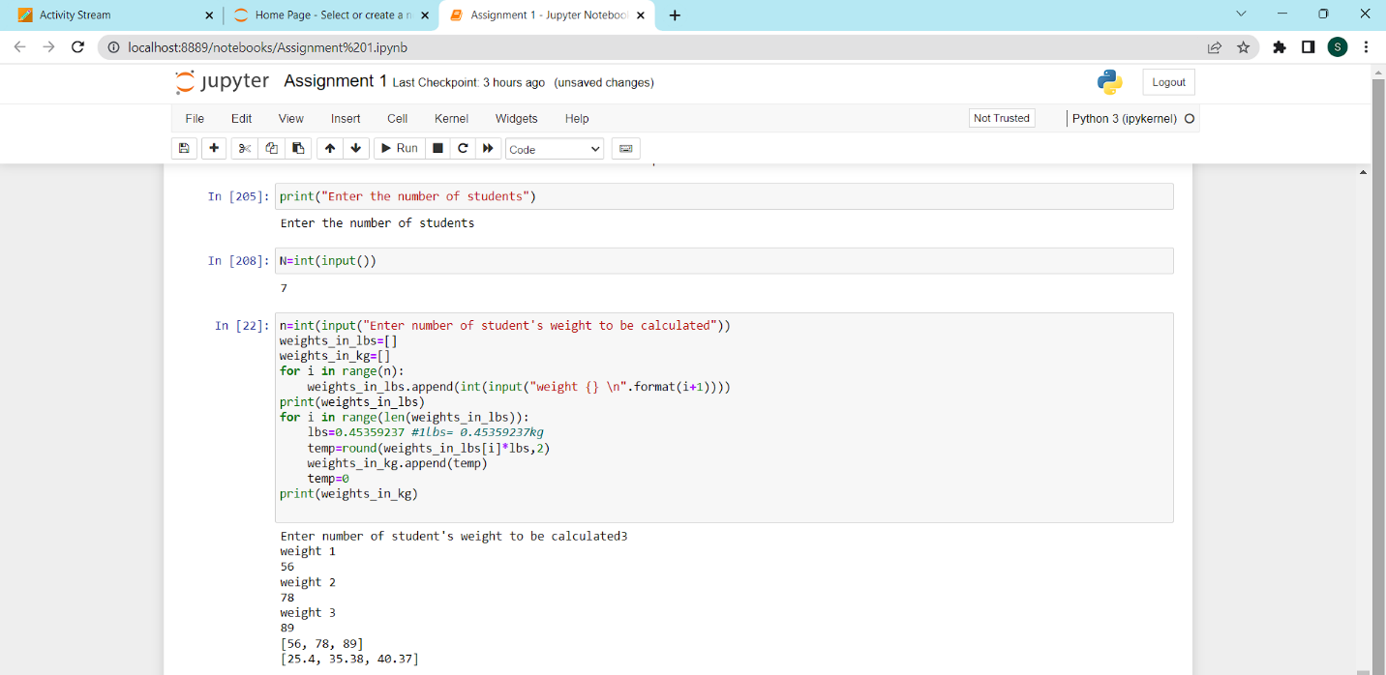

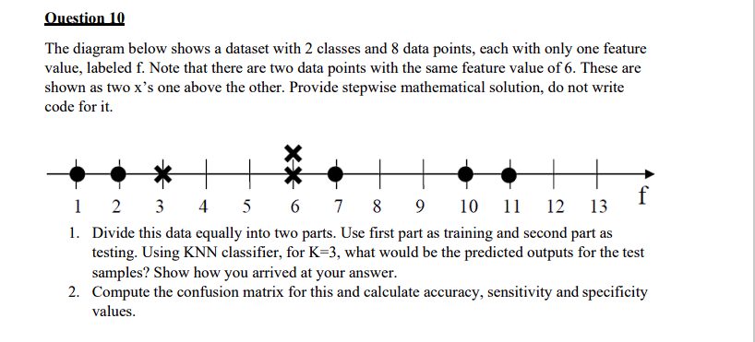

**Question 1**: We are dividing the data into two equal parts for training and test.

The first part which is the training data consists points of both dot and cross class which are (1,2) data points from dot class and (3,6) from cross class.

The second part which is the testing data consists data points (7,10,11) from dot class and (6) cross class.

Here we are using the KNN classifier for K=3.

* For point **6** of the testing data, the nearest neighbors are 6,3,2 from training data out of them 6,3 are from cross. Hence, the testing data point at 6 will be labeled as cross which is indeed what we have. So, this is a **correct** classification.
* For data point **7** in the testing data, we can see that the three nearest neighbors are 6,3,2 out of which 6, 3 are from cross class whereas 2 is from dot class. So, the testing data point at 7 will be labeled as cross where in it is actually a dot class. Hence, this is an **incorrect** classification.
* For data point **10** in testing data, the nearest neighbors are again 6,3,2 out of these as we already know 6 and 3 belong to cross class and 2 belongs to dot class. The data point 10 is labeled as cross class which is actually a dot. So, this is an **incorrect** classification.
* For data point **11** in the testing data, the nearest neighbors are again 6,3,2 out of these as we already know 6 and 3 belong to cross class and 2 belongs to dot class. The data point 11 is labeled as cross class which is actually a dot. So, this is an **incorrect** classification.

**Question 2:** True Positive (TP) = 25%

True Negative (TN) = 25%

False Positive (FP) = 75%

False Negative (FN) = 75%

**Accuracy** = (TP+TN)/(P+N) = (25+24)/200 = 0.25

**Sensitivity** = (TP)/(TP+FN) = TP/P= 25/100 = 0.25

**Specificity** = (TN)/(FP+TN) = TN/N = 25/100 = 0.25